` Student Number

***P E M***

**2017**

**TRIAL HIGHER SCHOOL CERTIFICATE EXAMINATION**

# Economics

|  |  |
| --- | --- |
| **General Instructions**Reading time – 5 minutes  * Working time – 3 hours * Write using blue or black pen * Write your Centre Number and Student Number at the top of this page, the Multiple-Choice Answer sheet, page 10, and the Answer Booklet provided. | **Total marks – 100****Section I** Pages 3-8 **20 marks**   * Attempt Questions 1-20 * Allow about 35 minutes for this part   **Section II** Pages 9-16  **40 marks**   * Attempt Questions 21-24 * Allow about 1 hour and 15 minutes for this section   **Section III** Page 17-18  **20 marks**   * Attempt either Question 25 OR Question 26 * Allow about 35 minutes for this section   **Section IV** Page 19  **20 marks**   * Attempt either Question 27 OR Question 28 * Allow about 35 minutes for this section |
| **Directions to School or College**  To ensure integrity and security, examination papers must NOT be removed from the examination room. Examination papers may not be returned to students till August 21st 2017. These examination papers are supplied Copyright Free, as such the purchaser may photocopy and/or make changes for educational purposes within the confines of the School or college.  All care has been taken to ensure that this examination paper is error free and that it follows the style, format and material content of the High School Certificate Examination in accordance with the Board of Studies requirements. No guarantee or warranty is made or implied that this examination paper mirrors in every respect the actual HSC Examination paper for this course. | | |

**BLANK PAGE**

#### Section I

**20 marks**

**Attempt Questions 1-20**

**Allow about 35 minutes for this section**

Use the Multiple Choice Answer Sheet provided.

Select the alternative A, B, C, or D that best answers the question. Fill in the response oval completely.

**Sample** 2 + 4 = (A) 2 (B) 6 (C) 8 (D) 9

A B C D

If you think you have made a mistake, put a cross through the incorrect answer and fill in the new answer.

A B C D

If you have changed your mind and have crossed out what you consider to be the correct answer, then indicate this by writing the word *correct* and drawing an arrow as follows:

*correct*

A B C D

1. Which of the following is an example of a discriminatory trade bloc?

A) EU

B) APEC

C) ASEAN

D) NAFTA

1. Which of the following is a characteristic of a high income economy?

A) High levels of literacy

B) Low levels of capital accumulation

C) High levels of labour intensive industries

D) High levels of development

1. Which of the following would most likely result in an increase in the budget deficit?
2. A decrease in government spending and a decrease in taxation
3. An increase in government spending and a decrease in taxation

C) A decrease in government spending and an increase in taxation

D) An increase in government spending and an increase in taxation

1. Other things being equal what would be the impact on Australia of interest rates increasing overseas?

1. Decreased capital inflow and a depreciation of the Australian dollar
2. Decreased capital inflow and an appreciation of the Australian dollar
3. Increased capital inflow and a deprecation of the Australian dollar
4. Increased capital inflow and an appreciation of the Australian dollar

**5**. Which of the following is an advantage of protection?

A) Greater availability and choice of goods and services for consumers

B) Balance of payments issues for all countries

C) The protection of jobs in inefficient industries

D) Greater diversity in local industry

**6**. The following information refers to a nation’s terms of trade:

|  |  |  |
| --- | --- | --- |
| Year | Import Price Index | Export Price Index |
| 2012 | 95 | 100 |
| 2013 | 106 | 102 |

What was the most likely effect of the change in this nation’s terms of trade over this period?

A) A fall in the financial account surplus

B) Less imports can be purchased with the given levels of exports

C) The country is highly inefficient in export industries

D) More imports can be purchased with the given levels of exports

# 

**7**. An increase in which of the following will most likely change a Gini- coefficient from 0.33 to 0.31

A) Regressive tax rates

B) The Goods and Services tax rate

C) Marginal income tax rates for low income earners

D) Tax rates levied on the profits from investments

Questions 8 refers to the following table for the economy.

|  |  |  |
| --- | --- | --- |
| **Country** | **CARS** | **WHEAT** |
| **UK** | 200 | 100 |
| **Australia** | 150 | 50 |

**8**. Which of the following statements is the most correct?

A) Australia has a comparative advantage in the production of cars

B) Australia has and absolute advantage in the production of wheat

C) The UK has a comparative advantage in the production of cars

D) Australia has a comparative advantage in the production of wheat

**9**. Why does cyclical unemployment occur?

A) Because weather conditions mean that jobseekers cannot always find jobs

B) Because of the business cycle changes

C) Because businesses only want skilled workers

D) Because of the time needed to match qualified job seekers with available job

openings

**10**. Which action by the Reserve Bank would slow down the economy in an economic boom?

|  |  |
| --- | --- |
| **CGS** | **Interest Rates** |
| A) Buy | Increase |
| B) Sell | Decrease |
| C) Sell | Increase |
| D) Buy | Decrease |

**12**. The table below shows selected data for an economy:

|  |  |  |
| --- | --- | --- |
| **Real GDP($bn)** | **Net foreign liabilities($bn)** | **Net foreign debt($bn)** |
| $1600 | 950 | 600 |

What is the value of net foreign equity as a percentage of Real GDP?

A) 21.9%

B) 59.3%

C) 63.1%

D) 37.5%

**13**. Use the following graph to answer question 13

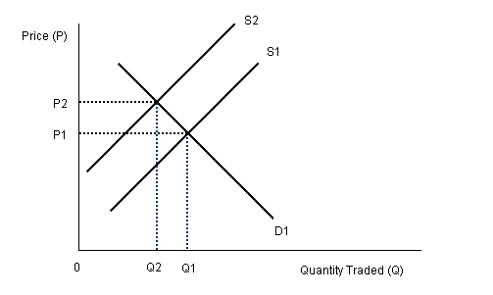

The graph depicts the value of Australia’s currency. What might have caused the change in the value of the dollar from P1 to P2?

A) An interest rate rise in Australia has seen a greater demand for its currency

B) Less economic growth had seen the consumers of Australia buy less imports.

C) Strong economic growth has seen the consumers of Australia demand more imports

D) There is less demand for overseas currencies

**14**. The Australian government has received interest on a loan from a developed country.

How will this be recorded in Australia’s balance of payments?

A) A credit in the primary income account

B) A debit in the primary income account

C) A debit in the capital and financial account

D) A credit in the capital and financial account

**15.** Over time a developing economy has adopted a range of economic policies to allow free movement of resources, protect intellectual property and allow competition into their markets. What is this economy experiencing?

|  |  |
| --- | --- |
|  | A) Privatisation |
|  | B) Convergence |
|  | C) Corporatisation |
|  | D) Divergence |

**16**. The table shows selected data for an economy

|  |  |
| --- | --- |
| **Year** | **CPI** |
| 1 | 94 |
| 2 | 96 |
| 3 | 100 |
| 4 | 110 |

Which of the following describes the measurement of inflation in this economy?

A) The base year is year 2 and the inflation rate in year 2 is 2%

B) The base year is year 3 and the inflation rate in year 3 is 10%

C) The base year is year 2 and the inflation rate in year 3 is 10%

D) The base year is year 3 and the inflation rate in year 4 is 10%

**17**. If there is an increase in the Marginal Propensity to Save (MPS).

Which combination of changes in the simple multiplier and equilibrium income is most likely to result?

|  |  |
| --- | --- |
| **Simple multiplier** | **Equilibrium income** |
| A) Increases | Increases |
| B) Decreases | Decreases |
| C) Decreases | Increases |
| D) Increases | Decreases |

**18**. The following diagram shows the imposition of a subsidy in a market.

P($)

S1

S2

S2

Q

D

D

S1

500

450

300

1000

2000

As a result of the subsidy, what is the difference in quantity put onto the market?

A) 1000

B) 2000

C) 200

D) 50

**19.** Economies in transition are moving away from an economy controlled by:

A) Central planning

B) Market forces

C) Deregulation

D) Microeconomic reforms

**20**. Which of the following could improve the international competitiveness of an economy?

A) The surplus in the government budget becomes a deficit

B) An increase in official interest rates

C) Wage increases in the manufacturing and services sectors

D) A currency depreciation

**END OF SECTION 1**

**Section II**

**Economics**

**40 marks**

**Attempt all questions**

**Allow about 1 hour and 15 minutes for this section**

**Question 21 (10 marks)**

|  |
| --- |
| **The World Bank Group has set two goals for the world to achieve by 2030:**   * **End extreme poverty by decreasing the percentage of people living on less than $1.90 a day to no more than 3%** * **Promote shared prosperity by fostering the income growth of the bottom 40% for every country**   **World Bank Goals, April 2017** |

|  |  |  |
| --- | --- | --- |
| A) | Discuss how economic growth and economic development are measured  …………………………………………………………………………………………  …………………………………………………………………………………………  …………………………………………………………………………………………  …………………………………………………………………………………………  ……………………………………………………………………………………… | **2** |

|  |  |  |
| --- | --- | --- |
| B) | Identify TWO nations that are categorised by the World Bank as developing  …………………………………………………………………………………………  …………………………………………………………………………………………  **Question 21 continues over the page**  **Question 21 (continued) Marks** | **1** |
| C)  D) | Discuss the reasons for the differences in income levels between nations **3**  …………………………………………………………………………………………  …………………………………………………………………………………………  …………………………………………………………………………………………  …………………………………………………………………………………………  …………………………………………………………………………………………  …………………………………………………………………………………………  ………………………………………………………………………………………  Evaluate the impact of Globalisation on global trade flows **4**  …………………………………………………………………………………………  …………………………………………………………………………………………  …………………………………………………………………………………………  …………………………………………………………………………………………  …………………………………………………………………………………………  …………………………………………………………………………………………  …………………………………………………………………………………………  …………………………………………………………………………………………  …………………………………………………………………………………………  …………………………………………………………………………………………  …………………………………………………………………………………………  …………………………………………………………………………………………  …………………………………………………………………………………………  …………………………………………………………………………………………  **End of question 21** |  |

**Question 22** **(10 marks)**

The following table contains economic data for a hypothetical economy

|  |  |  |  |  |  |
| --- | --- | --- | --- | --- | --- |
| YEAR | Import price Index | Export price index | CAD (% of GDP) | Net Foreign debt ($Bill) | GDP |
| 1 | 125 | 110 | 4.7 | 480 | 2.1bn |
| 2 | 135 | 115 | 5.8 | 490 | 2.25bn |
| 3 | 145 | 130 | 5.0 | 505 | 2.3bn |
| 4 | 155 | 160 | 4.1 | 525 | 2.33bn |

|  |  |  |
| --- | --- | --- |
| A) | Calculate the terms of trade for year 4 (show all workings)  ……………………………………………………………………………………..  …………………………………………………………………………………….. | **1** |
| B) | Calculate the value ($) of the Current Account Deficit for year 3 (show all workings)  ……………………………………………………………………………………..  …………………………………………………………………………………….. | **1** |
| C) | Outline TWO factors that could contribute to an improvement in an economy’s terms of trade over time  ……………………………………………………………………………………..  ……………………………………………………………………………………..  ……………………………………………………………………………………..  ……………………………………………………………………………………..  ……………………………………………………………………………………..  . | **2** | |

**Question 22 continues over page**

**Question 22** (continued)

|  |  |  |
| --- | --- | --- |
| D) | Describe how an increase in domestic interest rates could affect TWO components of the Balance of Payments  ……………………………………………………………………………………..  ……………………………………………………………………………………..  ……………………………………………………………………………………..  ……………………………………………………………………………………..  ……………………………………………………………………………………..  ……………………………………………………………………………………..  ……………………………………………………………………………………..  …………………………………………………………………………………….. | **3** |

|  |  |  |
| --- | --- | --- |
| E) | Explain ONE current government policy used to try and reduce Australia’s level of net foreign debt.  ……………………………………………………………………………………..  ……………………………………………………………………………………..  ……………………………………………………………………………………..  ……………………………………………………………………………………..  ……………………………………………………………………………………..  ……………………………………………………………………………………..  ……………………………………………………………………………………..  ……………………………………………………………………………………..  ……………………………………………………………………………………..  ……………………………………………………………………………………..  **End of question 22** | **3** |

**Question 23 (10 Marks)**

|  |
| --- |
| "The UN Climate Change Conference in Marrakech is the crucial next step for governments looking to operationalize the Paris Climate Change Agreement adopted last year. While the Paris Agreement gave clear pathways and a final destination in respect to decisive action on climate change, many of the details regarding how to move forward as one global community in that common direction still need to be resolved. Climate change is an issue that all countries need to address and to take positive steps towards slowing this process down “  The UN Climate Change Conference Marrakech , November 2016 |

A) Define the term renewable resources **1**

……………………………………………………………………………………………

……………………………………………………………………………………………

B) Distinguish between the private and the social costs of climate change **2**

……………………………………………………………………………………………

……………………………………………………………………………………………

……………………………………………………………………………………………

……………………………………………………………………………………………

……………………………………………………………………………………………

C) State and describe one positive externality that may occur as a result of climate change **2**

……………………………………………………………………………………………

……………………………………………………………………………………………

……………………………………………………………………………………………

……………………………………………………………………………………………

……………………………………………………………………………………………

……………………………………………………………………………………………

……………………………………………………………………………………………

**Question 23 continues over page**

D) Explain using examples, how government policies can achieve the economic objective of Environmental Sustainability **5**

………………………………………………………………………………………….

………………………………………………………………………………………….

………………………………………………………………………………………….

………………………………………………………………………………………….

………………………………………………………………………………………….

………………………………………………………………………………………….

………………………………………………………………………………………….

………………………………………………………………………………………….

………………………………………………………………………………………….

………………………………………………………………………………………….

………………………………………………………………………………………….

………………………………………………………………………………………….

………………………………………………………………………………………….

………………………………………………………………………………………….

………………………………………………………………………………………….

………………………………………………………………………………………….

………………………………………………………………………………………….

**End of question 23**

**Question 24** (**10 Marks)**

The table below shows information relating to a hypothetical economy

|  |  |  |  |
| --- | --- | --- | --- |
| YEAR | REAL GDP | UNEMPLOYMENT RATE (%) | CONSUMER PRICE INDEX |
| 2013 | 160,000,000 | 6.2 | 107 |
| 2014 | 180,000,000 | 5.8 | 115 |
| 2015 | 200,000,000 | 5.7 | 116 |
| 2016 | 215,000,000 | 5.5 | 120 |

A) Calculate the rate of real economic growth in 2016 (round off to one decimal place)  **1**

…………………………………………………………………………………………

…………………………………………………………………………………………

…………………………………………………………………………………………

B) Calculate the inflation rate for the economy for 2015 (round off to one decimal place)  **1**

…………………………………………………………………………………………

…………………………………………………………………………………………

…………………………………………………………………………………………

C) Identify ONE cause of an increase in the labour force participation rate and briefly explain TWO economic effects of this increase.  **3**

………………………………………………………………………………………….

…………………………………………………………………………………………

………………………………………………………………………………………….

…………………………………………………………………………………………

………………………………………………………………………………………….

…………………………………………………………………………………………

………………………………………………………………………………………….

…………………………………………………………………………………………

…………………………………………………………………………………………

**Question 24 continues over page**

C) Explain how macroeconomic policies can be used to promote price stability and full employment within an economy. **5**

…………………………………………………………………………………………

…………………………………………………………………………………………

…………………………………………………………………………………………

…………………………………………………………………………………………

…………………………………………………………………………………………

…………………………………………………………………………………………

…………………………………………………………………………………………

…………………………………………………………………………………………

…………………………………………………………………………………………

…………………………………………………………………………………………

…………………………………………………………………………………………

…………………………………………………………………………………………

…………………………………………………………………………………………

…………………………………………………………………………………………

…………………………………………………………………………………………

­­­­­­­­­­

**END OF SECTION II**

**Section III**

**Economics**

**20 marks**

**Attempt either Question 25 OR Question 26**

**Allow about 35 minutes for this section**

Answer the question in a writing booklet. Extra writing booklets are available.

In your answer you will be assessed on how well you:

* demonstrate knowledge and understanding relevant to the question
* use the information provided
* apply relevant economic terms, concepts, relationships and theory
* present a sustained, logical and cohesive response

**Question 25 (20 marks)**

**Analyse the impact of microeconomic policies on Australia’s unemployment and distribution of income.**

|  |
| --- |
| In most cases, employees are covered by Modern Awards. The two scenarios in which employees are not covered by Modern Awards are if they are employed under an Enterprise Agreement which excludes an Award, or if they receive a guaranteed annual income of over AU$136,700 (prorated for part-time employees).  The Awards have been modified and now fit into 122 industry and occupational Awards. It is also important to note that every year the Fair Work Commission conducts an annual wage review which can result in an increase to the minimum wages for particular job roles.  Source : <http://employsure.com.au/guides/modern-awards/> |

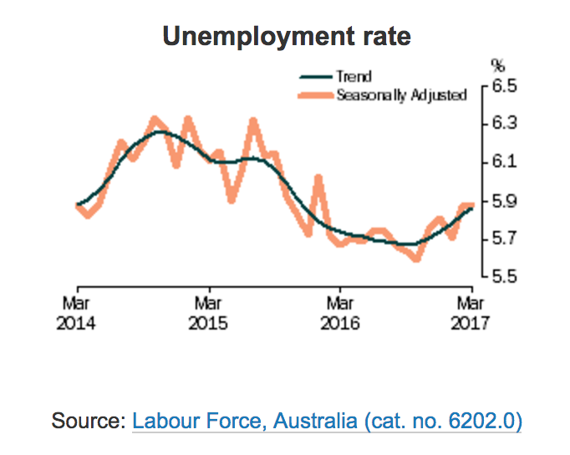

**OR**

**Question 26 (20 marks)**

**Discuss the effectiveness of Australia’s economic policy mix in achieving economic growth and environmental sustainability**.

|  |
| --- |
| ../../../../../../Desktop/Screen%20Shot%202017-05-08%20at%201.04.34%2 |

Source – T.Riley Year 12 Economics 2017

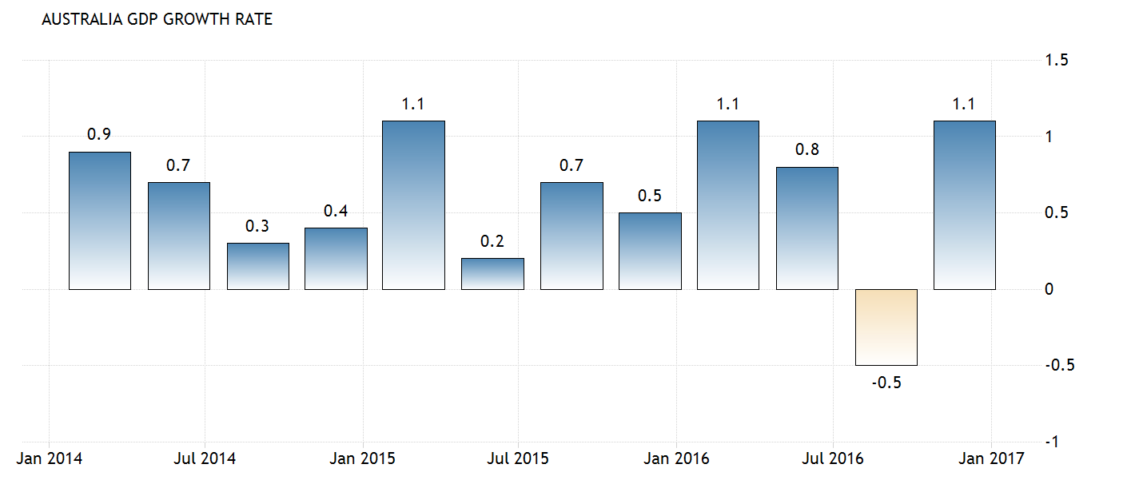

Source – www.trading economics.com

|  |
| --- |
|  |

**END OF SECTION III**

**Section IV**

**Economics**

**20 marks**

**Attempt either Question 27 OR Question 28**

**Allow about 35 minutes for this section**

Answer the question in a SEPARATE writing booklet. Extra writing booklets are available.

In your answer you will be assessed on how well you:

* demonstrate knowledge and understanding relevant to the question
* apply relevant economic information, terms, concepts, relationships and theory
* present a sustained, logical and cohesive response

**Question 27 (20 marks)**

**Explain how movements in the Australian dollar can affect the performance of the Australian economy**.

**OR**

**Question 28 (20 marks)**

**Analyse the impact of changes in the domestic and global economy on Australia’s external stability.**

**END OF PAPER**

** **

# Centre Number Student Number

**ECONOMICS – MULTIPLE-CHOICE ANSWER SHEET**

#### ATTEMPT ALL QUESTIONS

**Question**  **1** A B C D

**2** A B C D

**3** A B C D

**4** A B C D

**5** A B C D

**6** A B C D

**7** A B C D

**8** A B C D

**9** A B C D

**10** A B C D

**11** A B C D

**12** A B C D

**13** A B C D

**14** A B C D

**15** A B C D

**16** A B C D

**17** A B C D

**18** A B C D

**19** A B C D

**20** A B C D